Name: Nathan Keelan

Topic: Chapter 25

Key Individuals:

Franz Ferdinand – Archduke of Austria, his assassination at the hands of a Serbian activist, which led to Austria declaring war on Serbia which led to World War I.
Lawrence of Arabia – British officer stationed in the Middle East, incited Arab princes to revolt against the Ottomans and helped destroy Ottoman presence in the Middle East.
Paul von Hindenburg and Erich Ludendorff – became virtual dictators during the war, even eclipsing the power of the Kaiser. Hindenburg and Ludendorff mobilized Germany for total war.
Rasputin – Russian mystic, held great influence over Alexandra and the rest of the Romanov family.
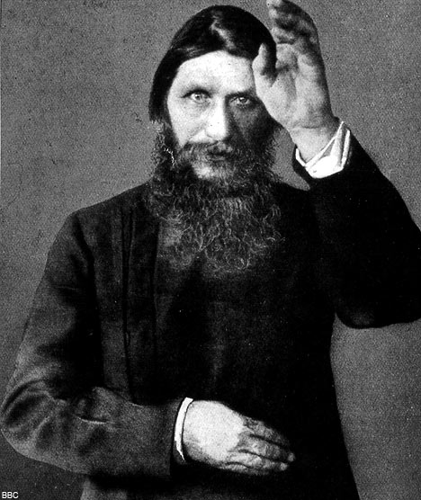

Nicholas II – the last tsar of Russia. He was a weak leader and was unable to prevent the collapse of the government. He eventually abdicated and was later assassinated.
Vladimir Lenin – leader of the Bolsheviks and extremely influential figure. He spearheaded the Bolshevik revolution and replaced the tsar rule with a communist system.
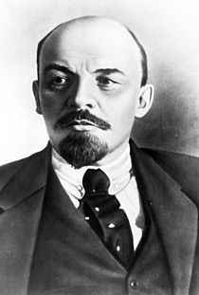
Alexander Kerensky – prime minister of the Russian provisional government.
Wilhelm II – last Kaiser of Germany. Abdicated and left the country directly before Germany surrendered and established a republic.
Woodrow Wilson – President of the United States, tried to enforce fourteen points that would ensure peace after the war.
The Big Four – David Lloyd George of Britain, Vittorio Orlando of Italy, Georges Clemenceau of France, and Woodrow Wilson of the US.
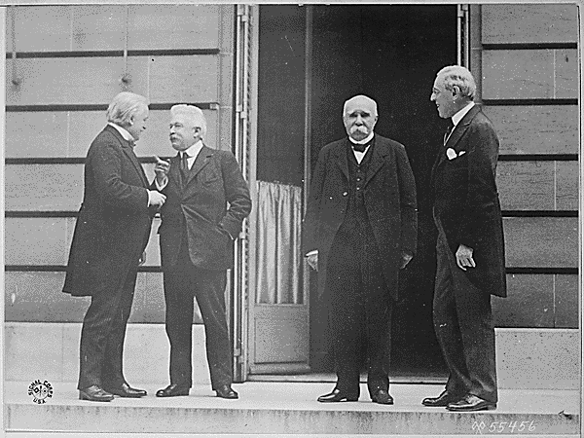

Key Events:

The assassination of Franz Ferdinand – Ferdinand was assassinated by Serbian terrorists who wanted the creation of a pan-Slavic kingdom. His assassination led to Austria (backed by Germany) declaring war on Serbia (backed by Russia) and eventually led to World War I.
World War I – fought between the Allied powers and the Central powers. World War I was the result of technological advancements, intense nationalism, international competition, and various political and economic reasons.
The Battles of Tannenberg – The Battles of Tannenberg saw an end to Russia being a threat to Germany.
United States entrance into the war – Germany refused to stop sinking ships in European areas with American passengers aboard. The US entered the war on the side of the allies.
Easter Rebellion – Members of the Irish Republic Brotherhood and Citizens Army occupied government buildings in Dublin on Easter Sunday in 1916. British officials crushed the rebellion and condemned the leaders to death.
February Revolution – A series of strikes broke out in Petrograd due to working class struggles and bread rationing. Nicholas II ordered troops to break up the strikes, but instead a large numbers joined the protestors. The tsar had lost control, he abdicated on March 15th, the same day the Duma established a provisional government.
Bolshevik Revolution – Lenin was falsely accused of trying to overthrow the government, so he responded by actually overthrowing the government. General Lavr Kornilov attempted to seize power with a march on Petrograd. Kerensky turned to the Petrograd Soviet for help, but inadvertently showed Lenin how weak he was. With the help of Leon Trotsky Lenin seized Petrograd on November 6th. He broke up the Constituent Assembly by force.
Russian Civil War – fought between the Reds (Soviets) and the Whites (Anti-Soviets). The Red army was forced to engage the white on many different fronts, but managed victory. One reason for the Red victory was the fact that all the Whites had in common was that they were Anti-communist.
The Second Battle of the Marne – The Second Battle of the Marne saw the defeat of the German army. The battle was significant because it signaled the end of Germany’s chances in the war, they surrendered soon after.
Treaty of Versailles – The Treaty of Versailles officially ended World War I. The conference was dominated by The Big Four, and almost every provision of the treaty was aimed at punishing Germany.

Abstracts:

By the early twentieth century many European countries were under the impression that their allies were important and that their security depended upon supporting those allies, even when they took foolish risks. Every nation-state regarded itself as subject to no higher interest or authority than themselves.

The Schlieffen Plan was Germany’s plan for victory in World War I. It mainly involved crossing Belgium, defeating France, and then focusing on Russia.

Government propaganda successfully stirred up nationalist antagonisms before the war and gave everyone a sense of optimistic righteousness. Soldiers on all sides of the conflict felt that their nation’s cause was just and that war would be relatively painless and over in a few months.

Trench life at the Western front was one of perpetual confusion and horror. During attacks the noise, machine-gun fire, dust, and exploding shells caused mass confusion and panic.

The need to organize masses of men and military material led to an increase in the central power of all European governments, economic regimentation, and manipulation of public opinion to keep the war going.

War caused European governments to expand power over their economies. Governments experimented with price, wage, and rent controls, rationing of food supplies, regulation of trade, and the nationalization of transportation industries.

A soviet was a council of workers’ and soldiers’ deputies. The Petrograd soviet represented the more radical interest of the lower classes and was comprised of socialists. They wished to establish peasant socialism by seizing the landed estates and creating a rural democracy.

Mensheviks wanted the Social Democrats to be a mass electoral socialist party based on a Western model. The Bolsheviks, under the leadership of Vladimir Lenin, became dedicated to a violent revolution to destroy the capitalist system.

Army Order No. 1 encouraged Russian military forces to remove their officers and replace them with committees composed of “the elected representatives of the lower ranks.”

Wilson’s Fourteen Points justified the enormous military struggle being waged. They spelled out “open covenants of peace”, reduction of national armaments, and the concept of self-determination. European nations complicated matters because they were guided by more pragmatic motives and national interests. He was almost completely unsuccessful in getting them implemented.

Key Themes and Movements:

Nationalism – extreme nationalism spread across Europe in the 19th and 20th centuries and was one of the main causes of World War I. Many countries were keen to defend their land, prove their country was the best, and defend their allies.

Militarism – in the century leading up to World War I there were little military conflicts but that didn’t mean there wasn’t the technology. In the years leadings up to and during the war military technology advanced greatly, with airplanes and tanks making their first appearances. European military machines had doubled in size between 1890 and 1914. As armies grew, so did the influence of military leaders, most of whom had very inflexible strategies, this forced political leaders to make decisions for military rather than political reasons.

Socialism – Socialism had its roots in the 19th century but it really came into prominence in the 20th. Many European countries such as Germany and Russia had very strong socialist parties. Furthermore, during the war many countries found themselves forced to take a stronger hand in economic affairs to ensure production for the war, so socialism spread to areas where it had not before made much of an impact.
Communism – The Bolshevik Revolution in 1917 saw the rise of the first communist ruled country. In the following decades the Soviet Union and its influence on the countries around it would come to be one of the most controversial and important issues in the world.

Cultural and Intellectual Movements:

The Lost Generation – refers to the generation that came of age during World War I. The term was popularized by Earnest Hemingway, who used it to refer to the mindset this generation in the post-war world. This generation included famous artists such as F. Scott Fitzgerald and T.S. Elliot.

European art during the Great War was characterized by the same confusion, pain, and fear that soldiers experienced in the front lines. A painting by John Singer Sargent entitled Gassed exemplifies this style, it depicts “soldiers being led from the battlefield – alive, but changed forever by individual encounters with deadly hazard in war.”

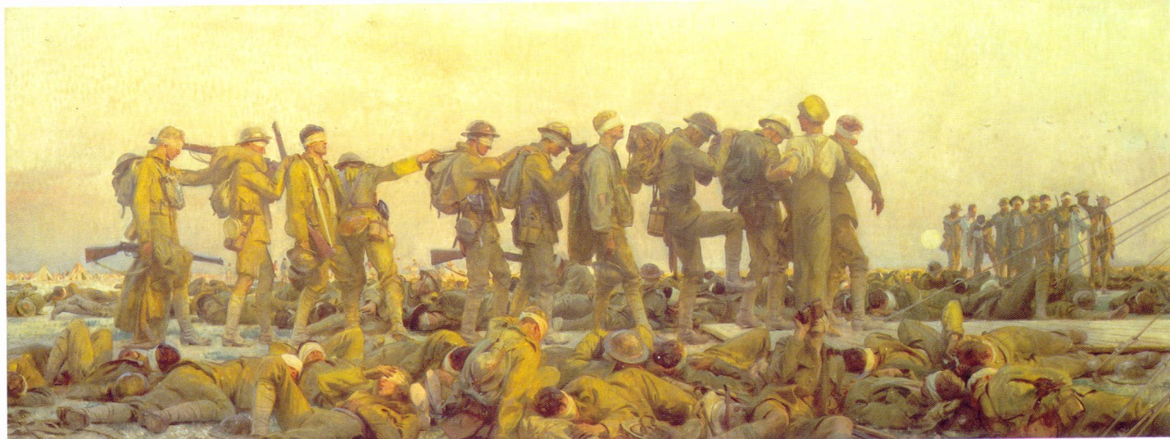

Necessities:

World War I – changed the face of war forever and the way it was viewed by governments and citizens.

Bolshevik Revolution – resulted in the first communist government that would result in the Cold War and Red Scare in the coming decades

Treaty of Versailles – Ended World War I, heavily punished Germany and created a number of new countries in Central and Eastern Europe.

Article 231 – “The War Guilt Clause” placed blame for the war completely on Germany and demanded that Germany pay reparations to the Allied countries. The humiliation and economic suffering this placed upon the German people later helped give rise to some Austrian guy with a stupid moustache.

